

Data Warehousing & Business Intelligent

3rd Year, 1st Semester

# Assignment 2

Submitted to

Sri Lanka Institute of Information Technology

Bachelor of Science Special Honors Degree in Data Science

IT20038700

S.A.C.H.Senadeera

Weekend Batch

Step 1: Data source

Data Warehouse design at the **Assignment 1** is used as the data source for this Assignment. Data Warehouse consists of 6-dimension tables and one fact table(SalesFact) to represent Superstore data altogether.

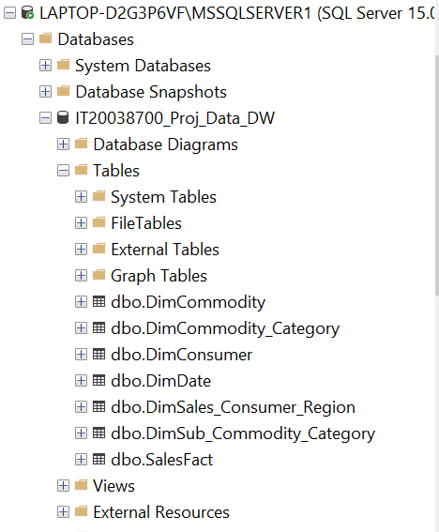

ER Diagram for Source System

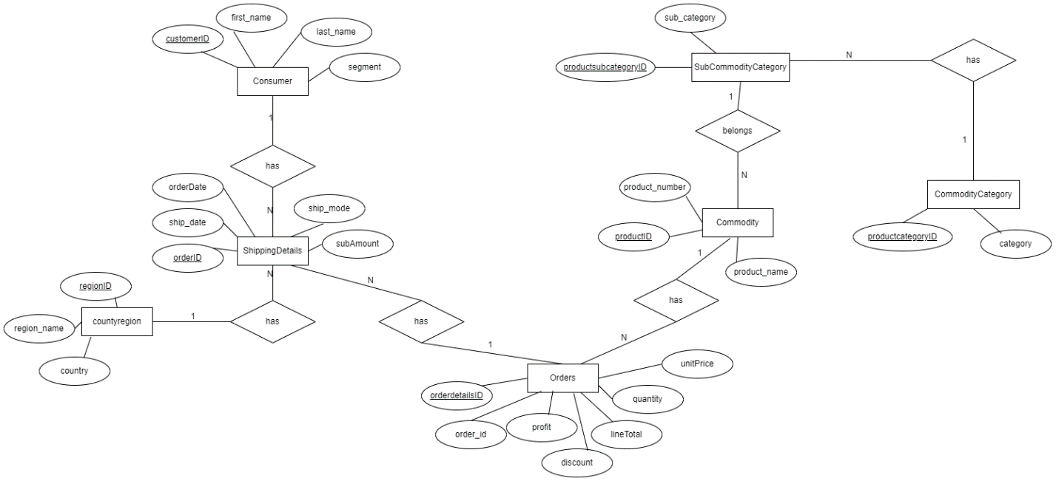

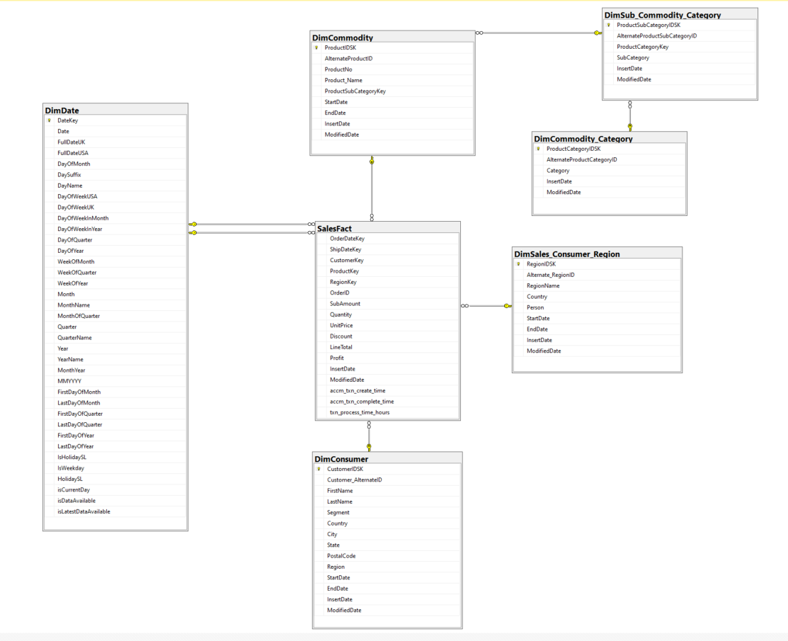Data Warehouse Diagram

Step 2: SSAS Cube Implementation

SSAS cube implementation is followed with several steps.

1. **Project Creation**

SSAS project is created in Visual studio for the Superstore data in data warehouse. The  
project is renamed to **IT20038700_Proj_Assignment1.**

1. **Data Source Configuration**

In the created project, data source folder is selected under the **IT20038700_Proj_Assignment1**  
package. After creating a connection to the MS SQL server, ‘the **IT20038700_Proj_DATA DW**’ database in SQL server has been selected as the data source.

1. **Data Source View Configuration**

In the Data Source View Wizard, configured data source has been selected. Then the  
necessary tables and views required for cube design has been selected as shown below.

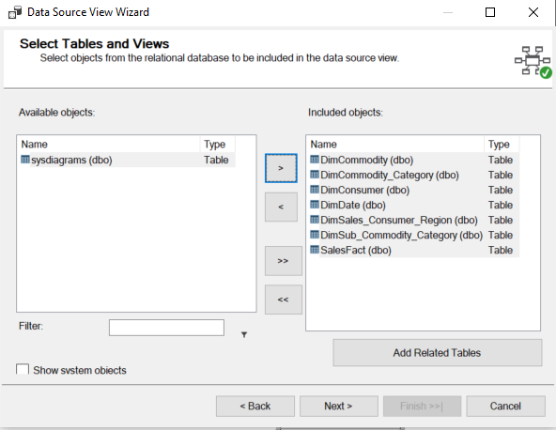

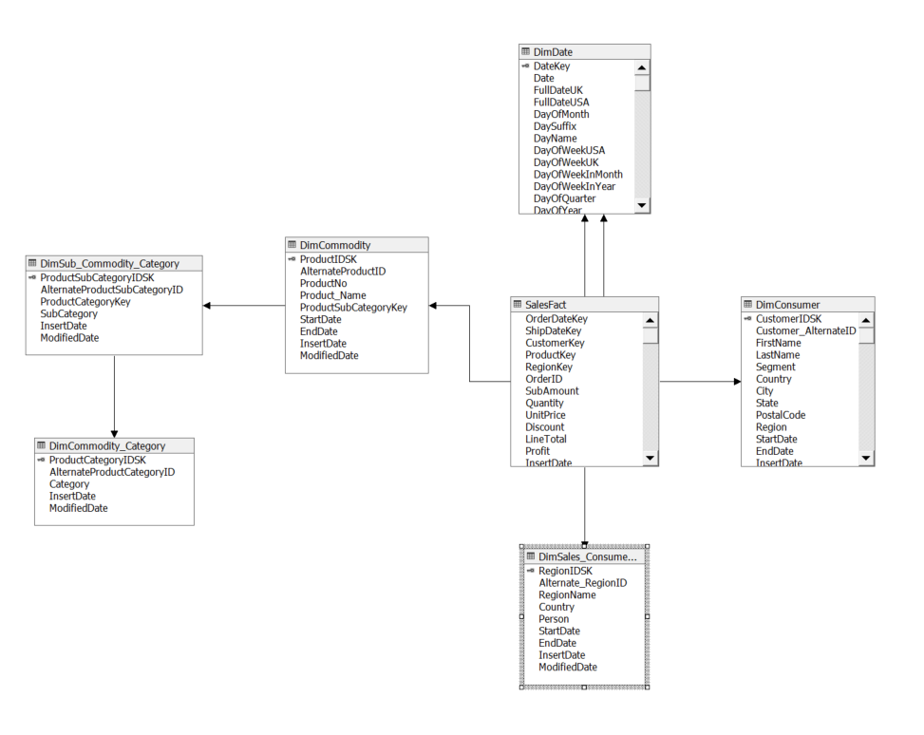Data Source View

1. **Cube Design**

In the Cube wizard SalesFact has been selected as the Measure table and DimCommodity,  
DimCommodity_Category, DimSub_Commodity_Category, DimDate, DimConsumer and DimSales_Consumer as dimension tables for the cube.

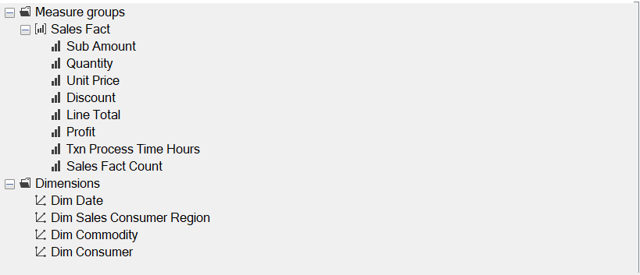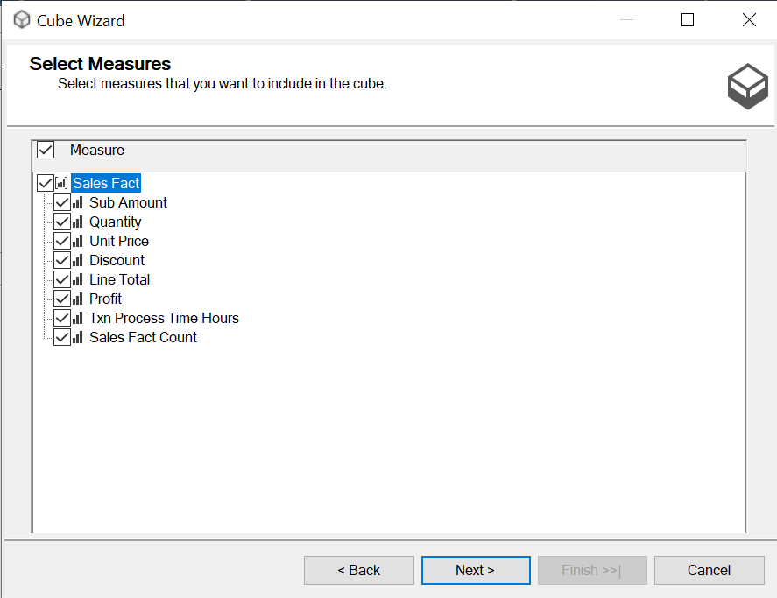

Cube Design

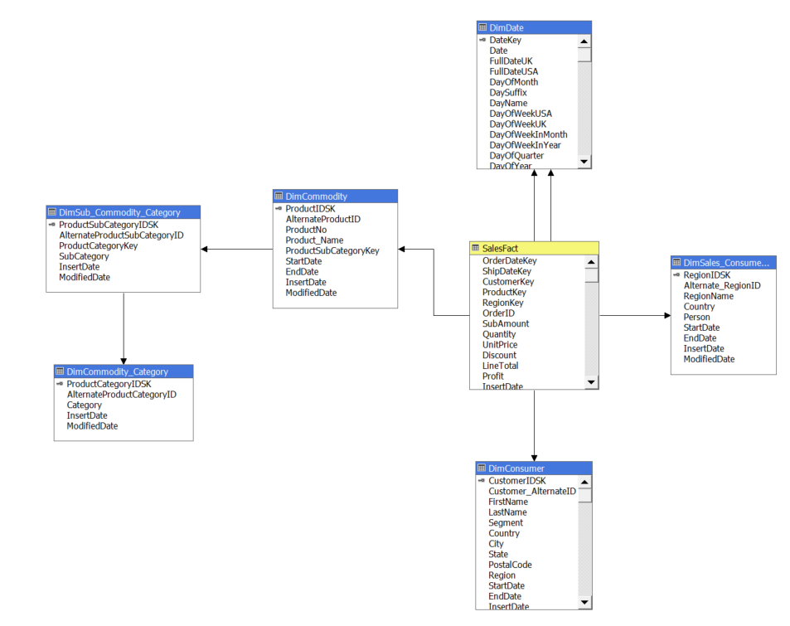

1. **Cube Implementation**

**Implementing Hierarchies**

* Hierarchies on DimDate

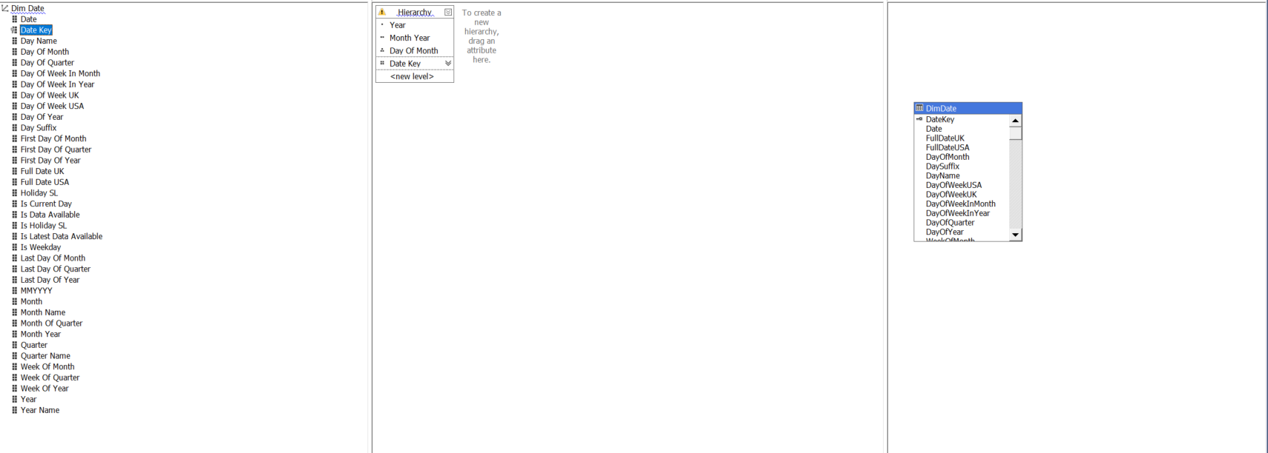

* Hierarchies on DimConsumer

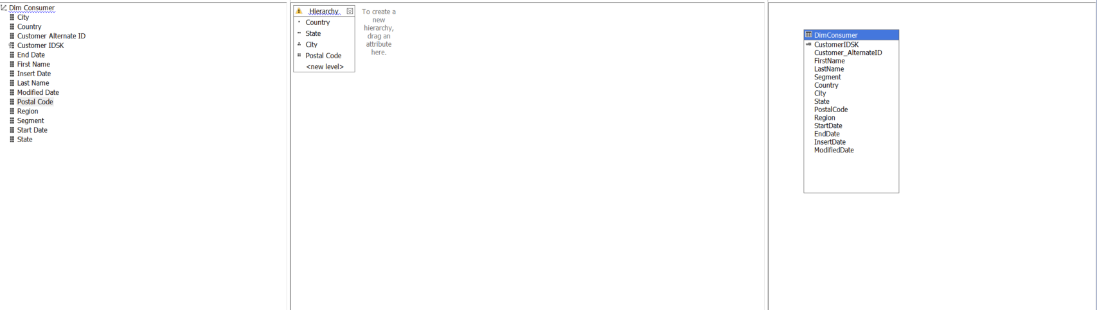

Then the SSAS was deployed in SQL server management studio. The deployed data cube contains the SalesFact measure table with DimCommodity, DimConsumer, Dim Date, Dim Sales Consumer Region dimension tables.

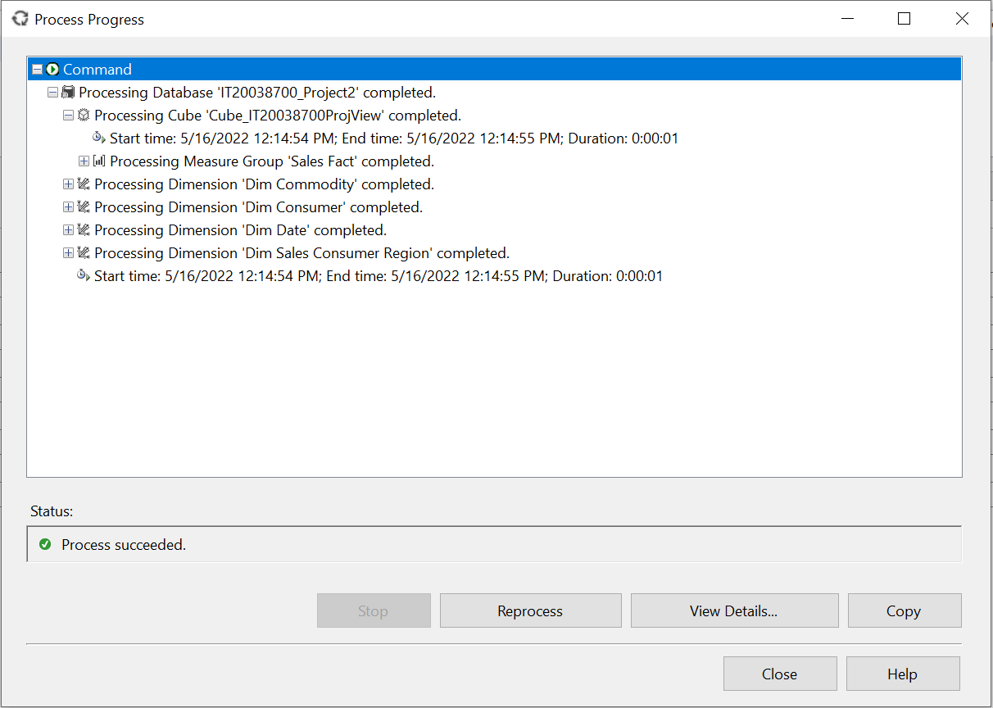

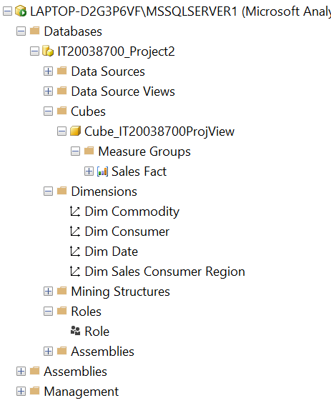

**KPI Creation**

KPI is designed on SubAmount attribute of Measures. It checks if the SubAmount is more than $50. If so  
value is set to success(True) else set to fail(False).

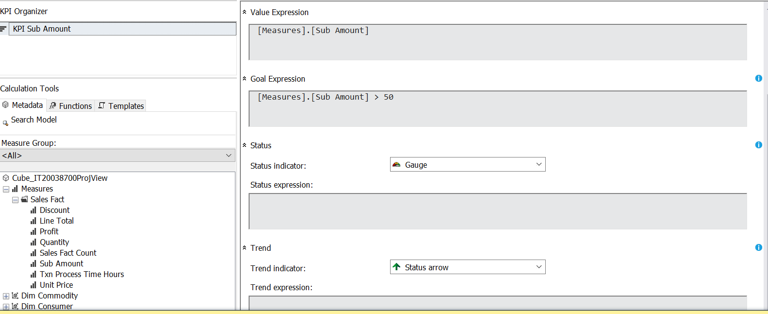

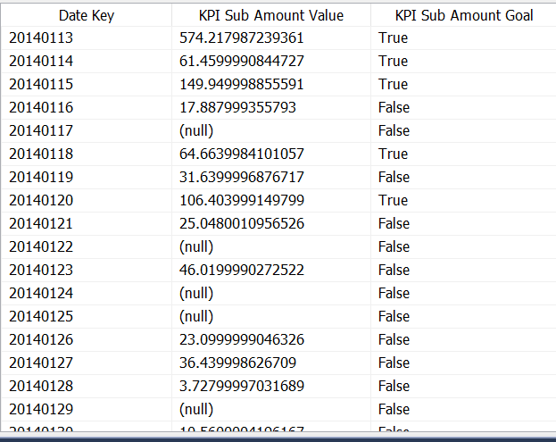

Step 3: Demonstration of OLAP Operations

In the data tab of excel Microsoft analysis services are selected from other sources. There the  
relevant database to create the pivot table i.e. Cube_IT20038700ProjView database is selected. Then the data there gets imported as a pivot table report.

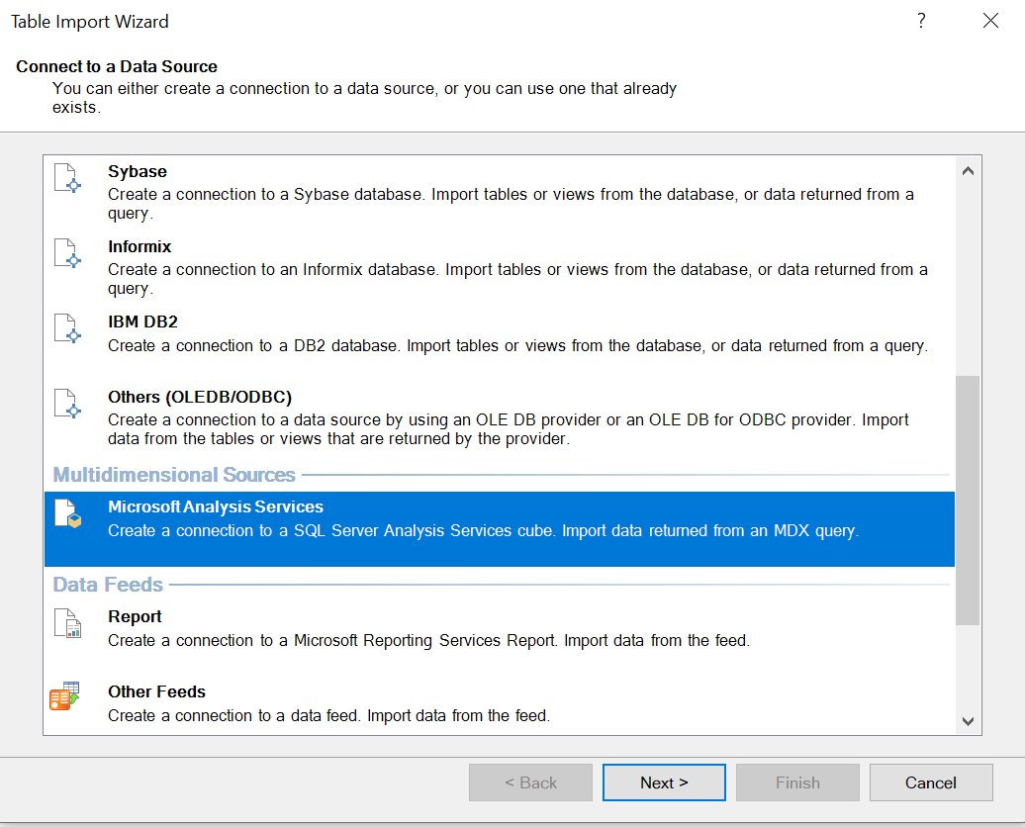

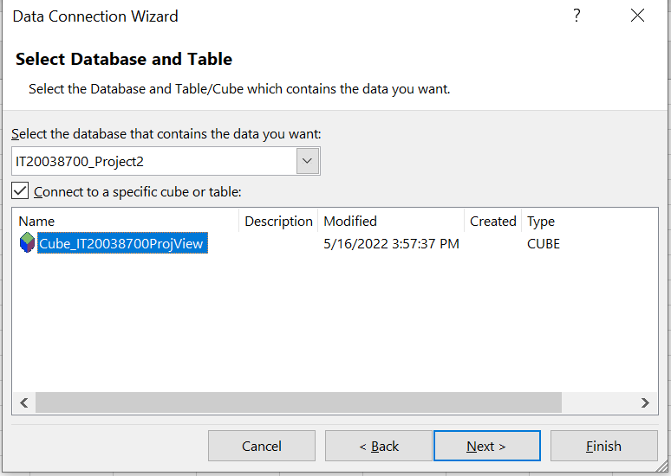

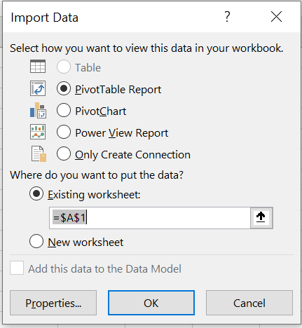

1. **Roll-Up**

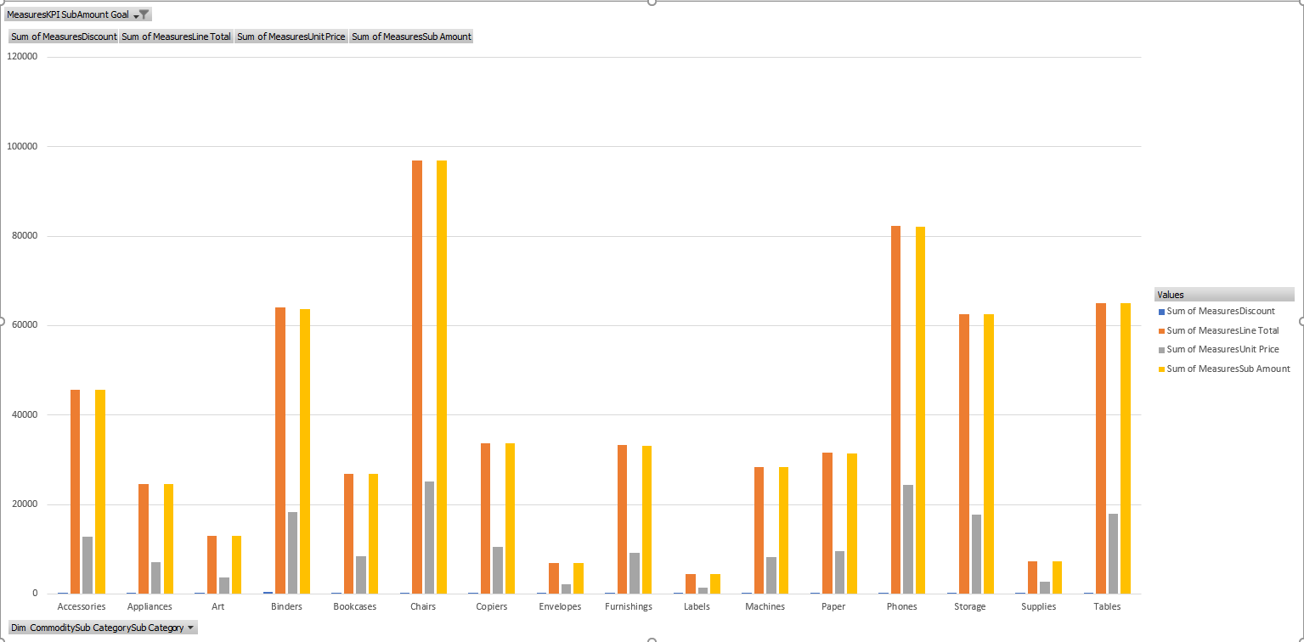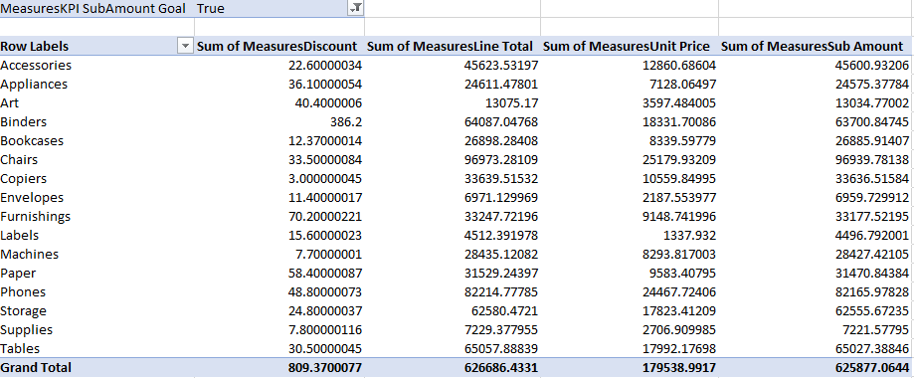It can be seen Product Discount, Line Total, Unit Price and the Sub Amount is displayed for each Sub Category type. High level understanding can be obtained.

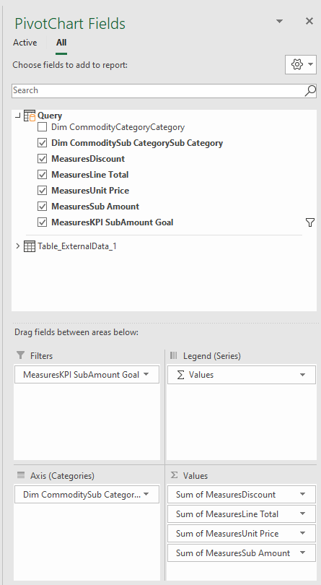

1. **Drill-Down**

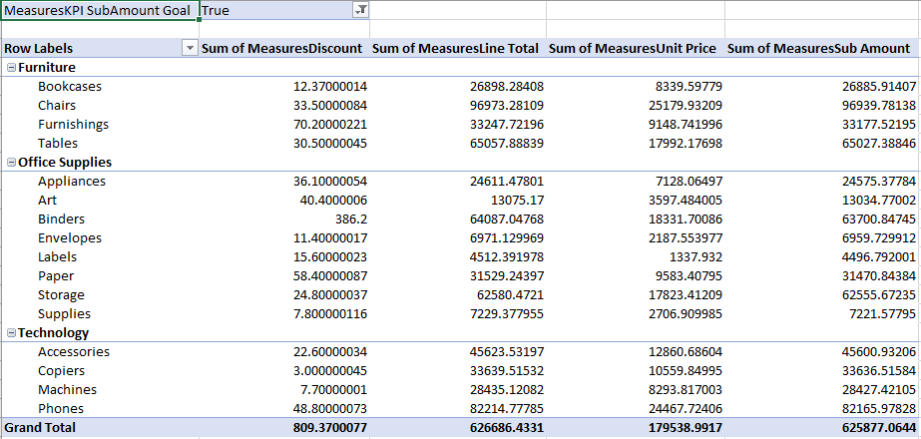In depth understanding of Superstore details for each Sub Category type on each Category can be obtained through the completely drilled down pivot table.

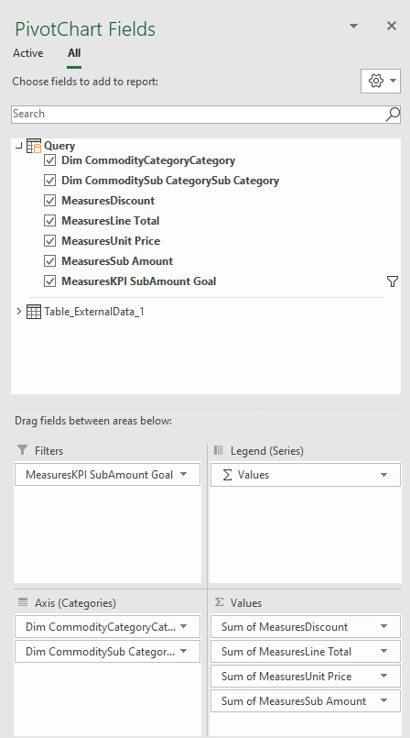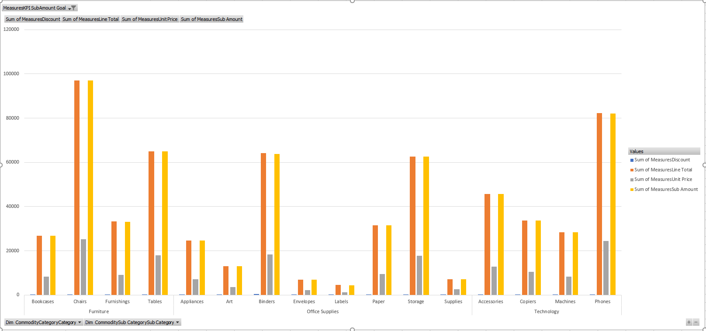

1. **Slice**

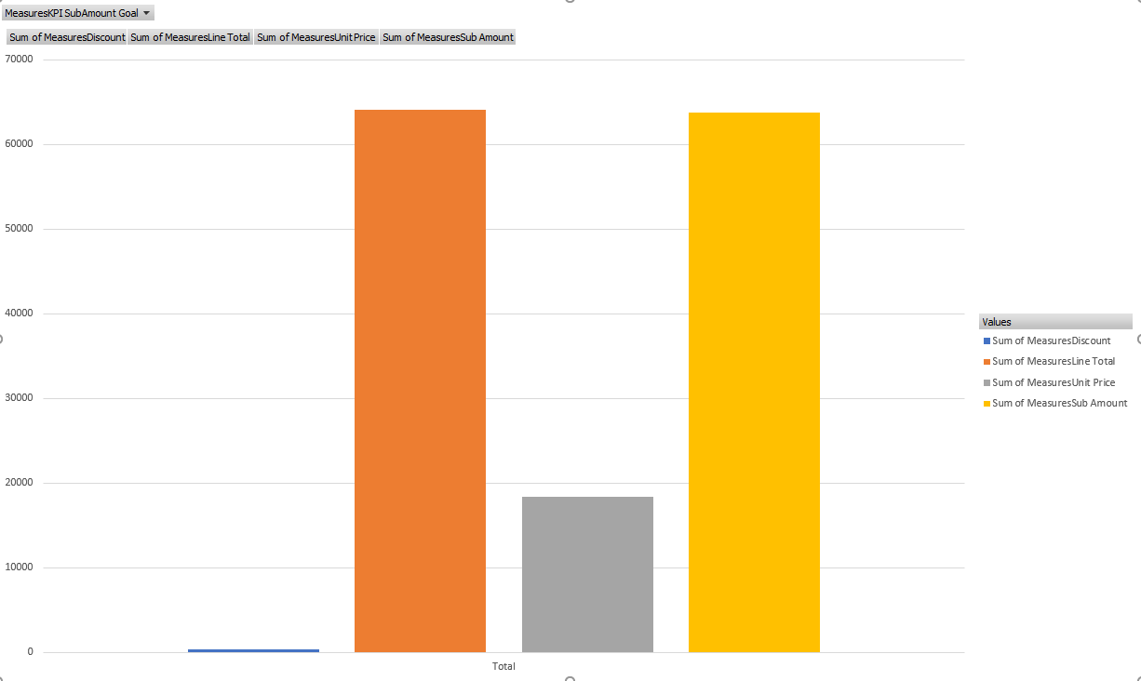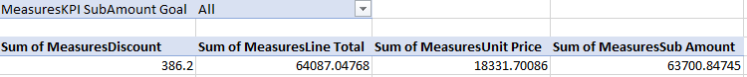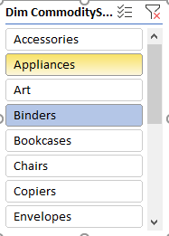

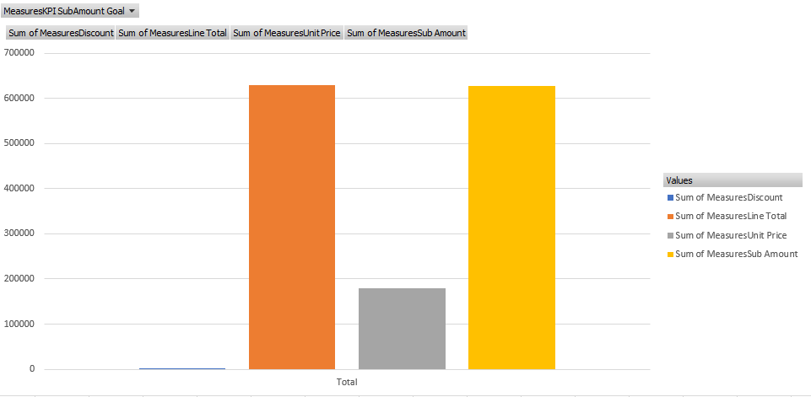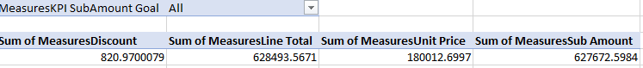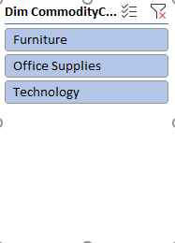

1. **Dice**

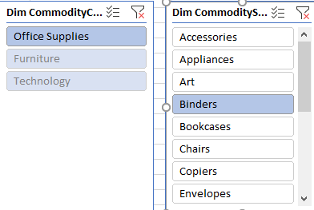A new column-wise categorization is introduced so that values can be filtered in two dimensions.

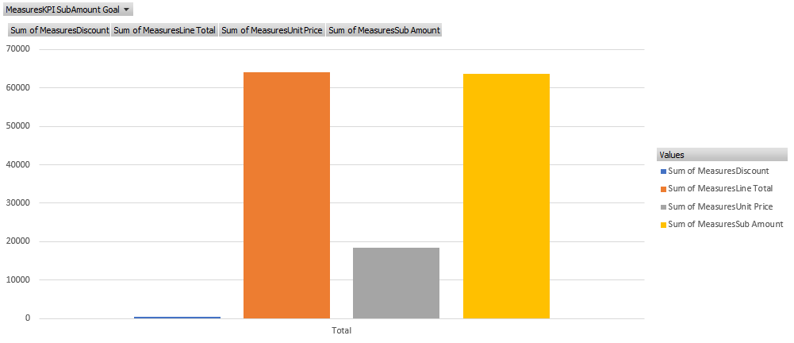****

Step 3: SSRS Reports

* **Used Tools :-**  
  Report server  
   SSRS web portal  
   Report Server Configuration Manager  
   Report Server database

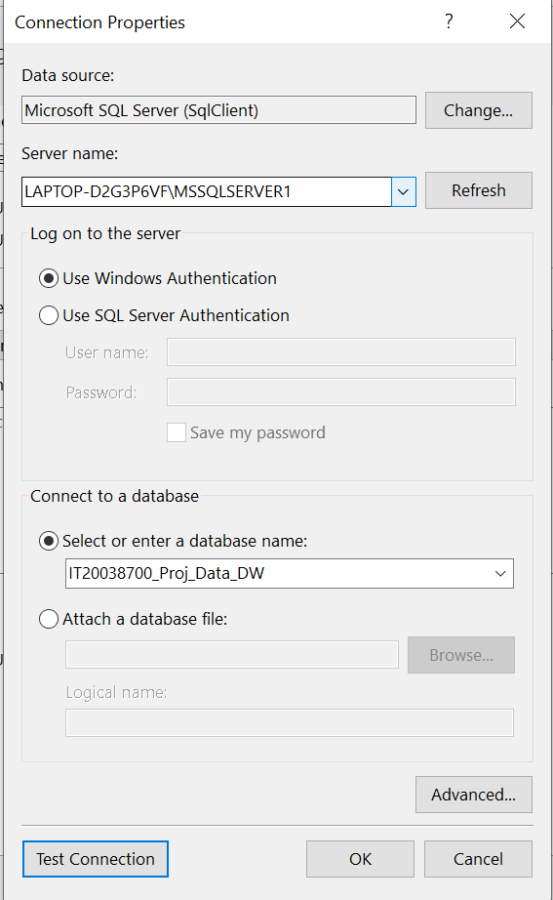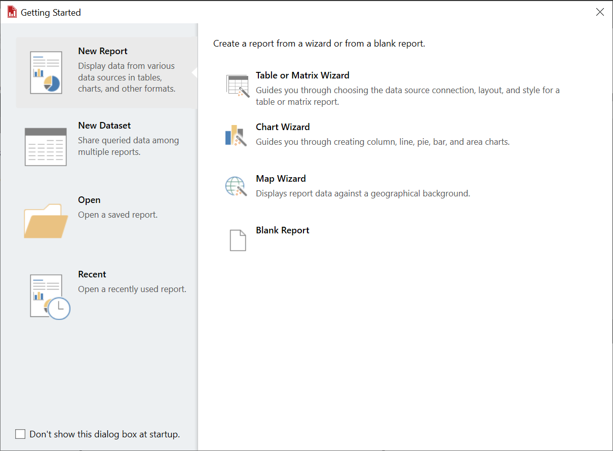Preparation  
Connection has been set to the data warehouse in report builder

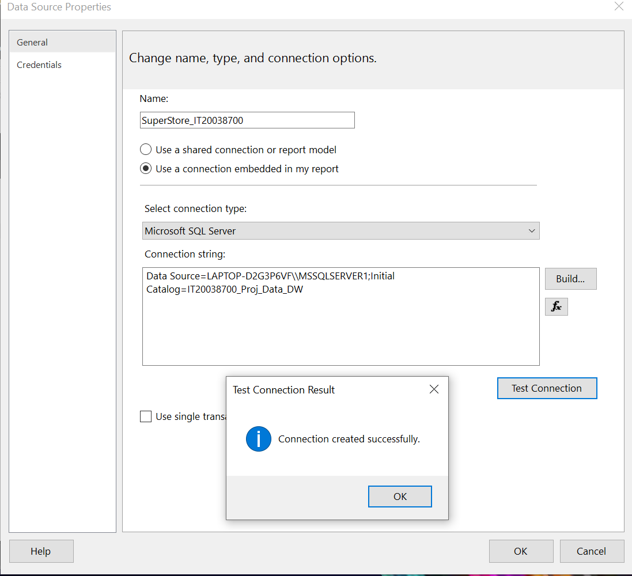

1. Report 1: Report with a matrix

Report with row of labels and column of labels is created. Commodity Quantity, Line Total and Sub Amount received by each **Year** can be observed through this report.

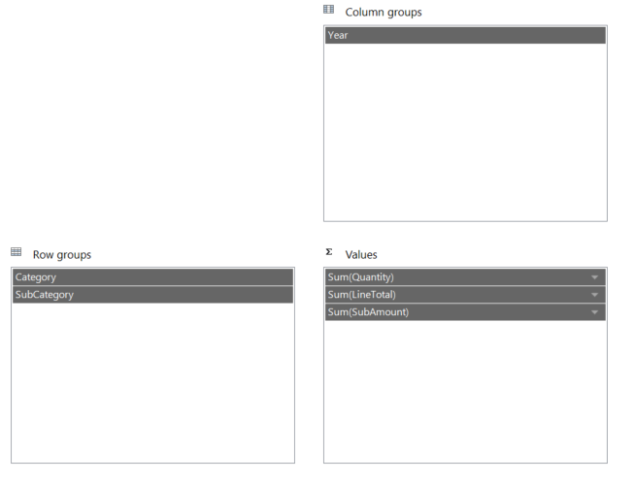

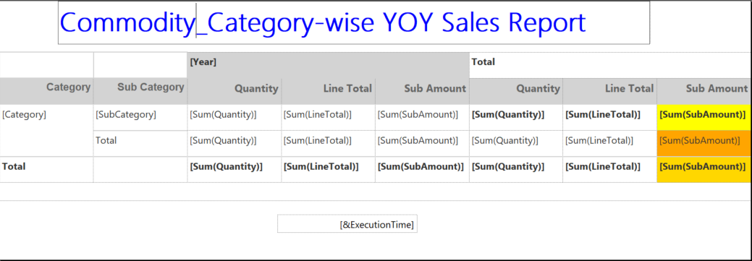

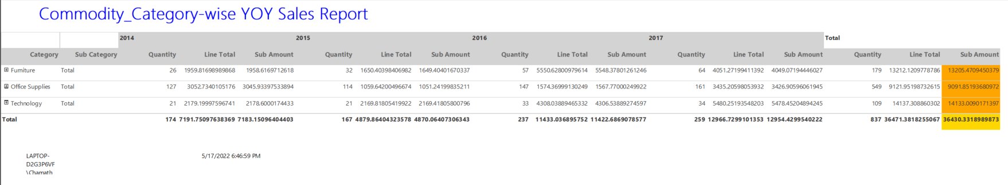

1. Report 2: Report with more than one parameter

Data in a given commodity Category in a given Sub Category can be observed though this report.

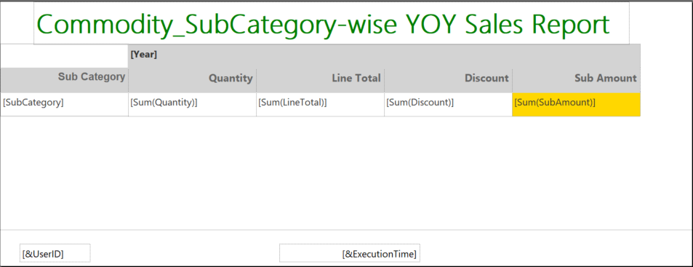

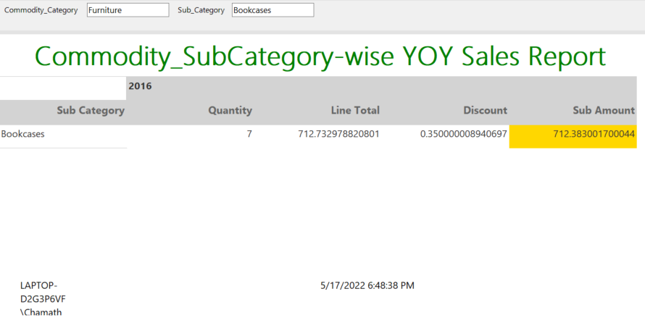

1. Report 3: SSRS Drill Down Report

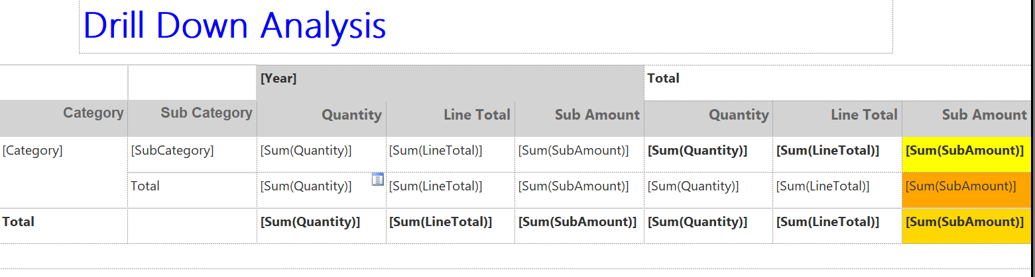

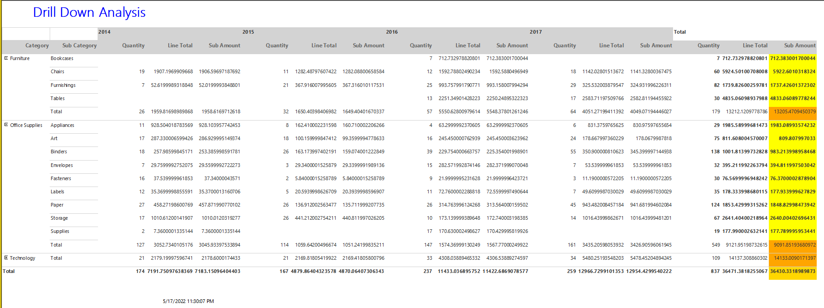

1. Report 3: SSRS Drill Through Report

Report to represent Sub Amount and Line Total for a given year has been created. Further For each Category it can be checked whether the amount is gained through Which Sub Category by clicking on columns of the column chart. Then it will be directed to another report with chart.

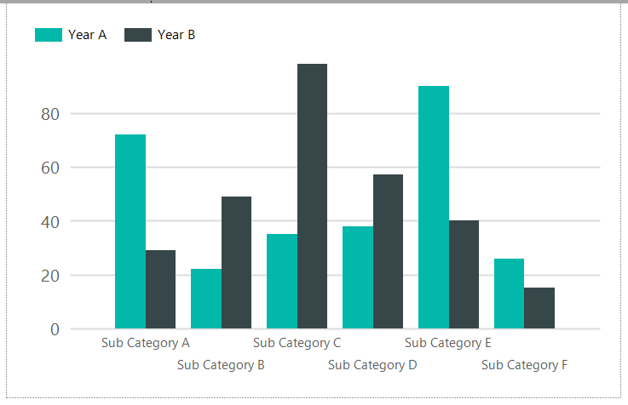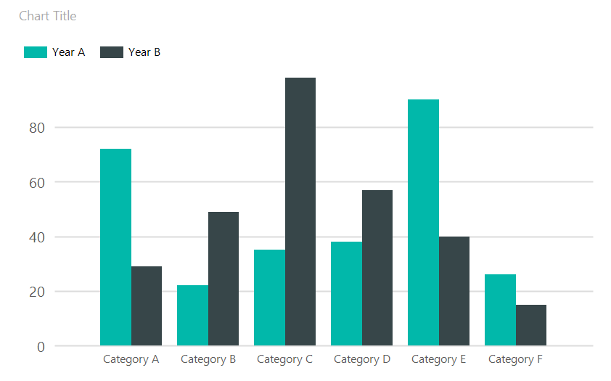

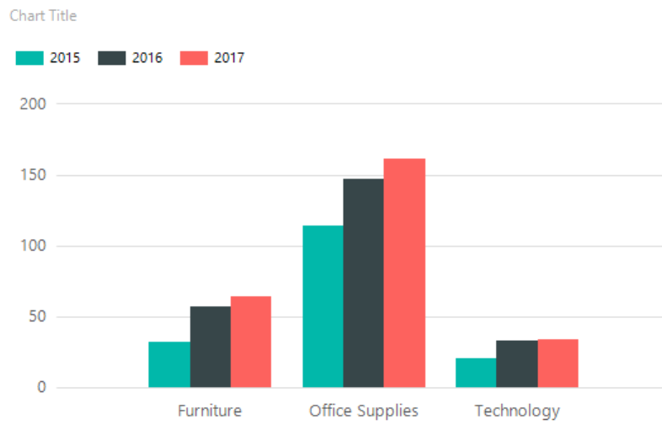

In order to perform the drill through necessary parameters should be set on the first report as  
shown below.

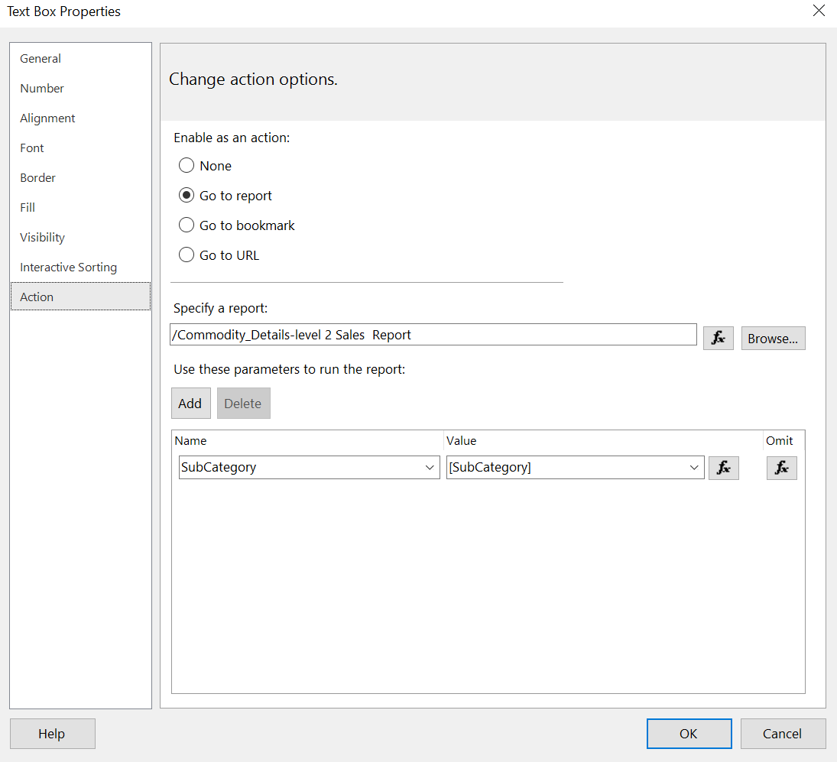

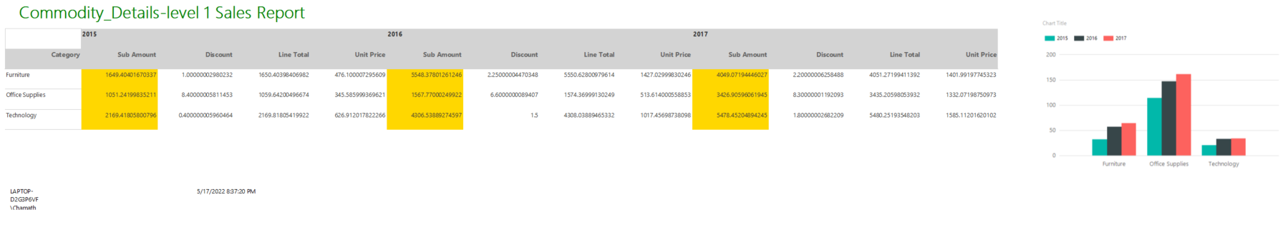

On click of the Category of the above report user gets directed to the below Another chart.

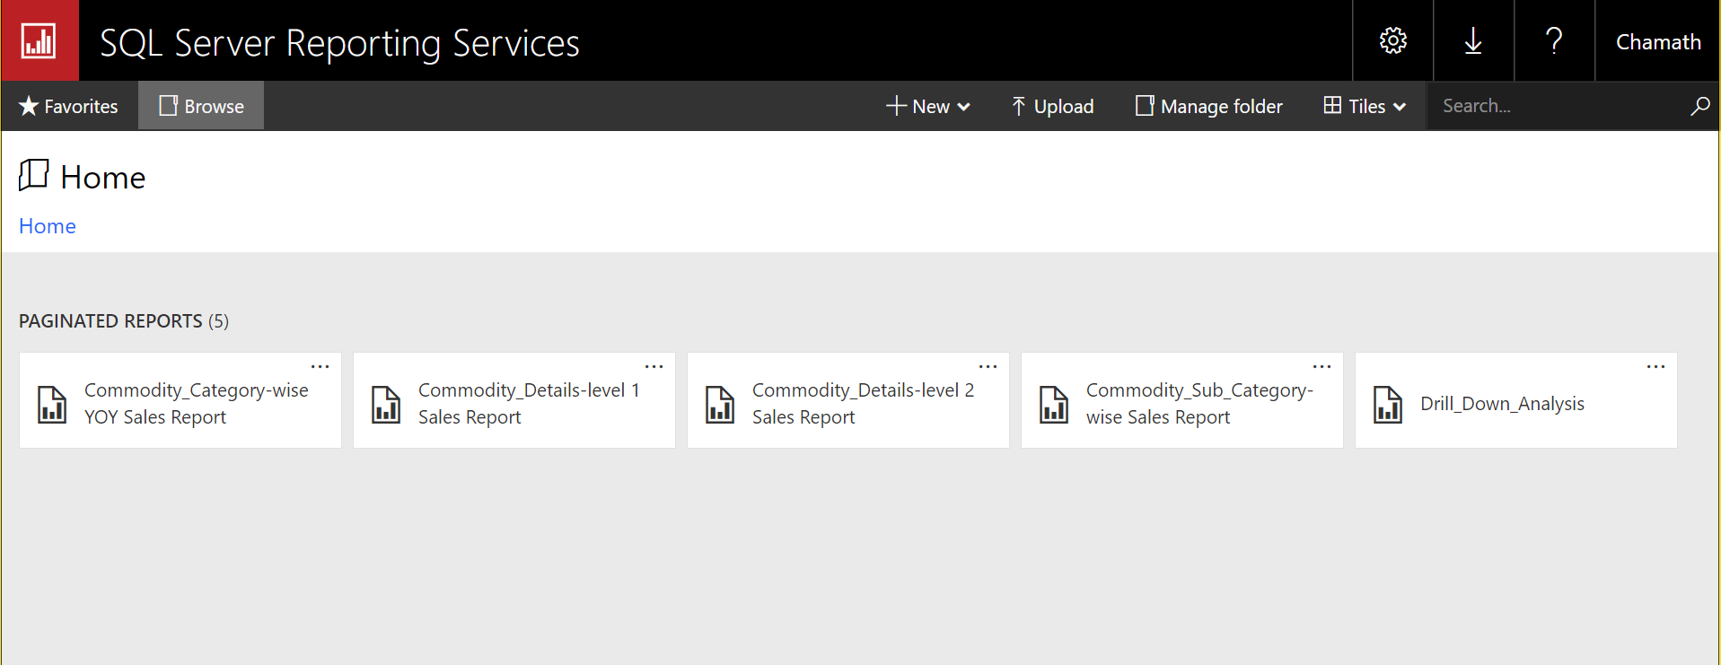Final set of reports: 